Lab 7:
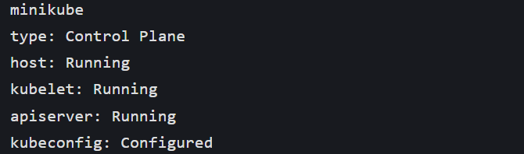
Download Istio
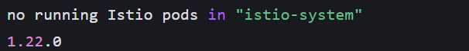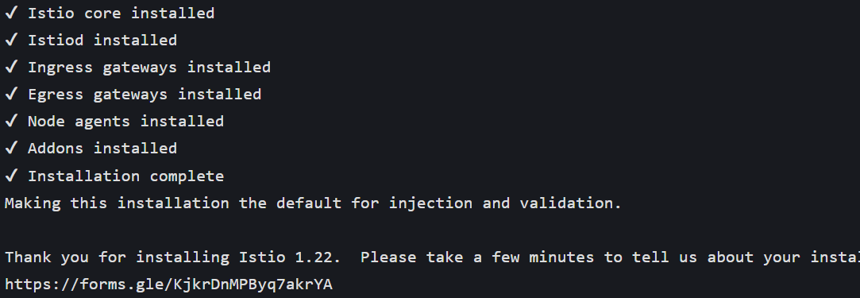Verify Istio Installation
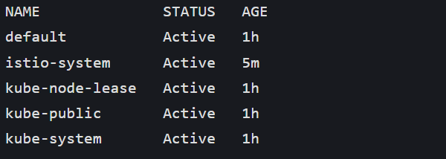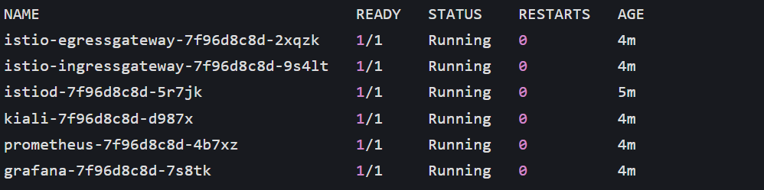Enable Automatic Sidecar Injection
Step 2: Deploy the Bookinfo Sample App
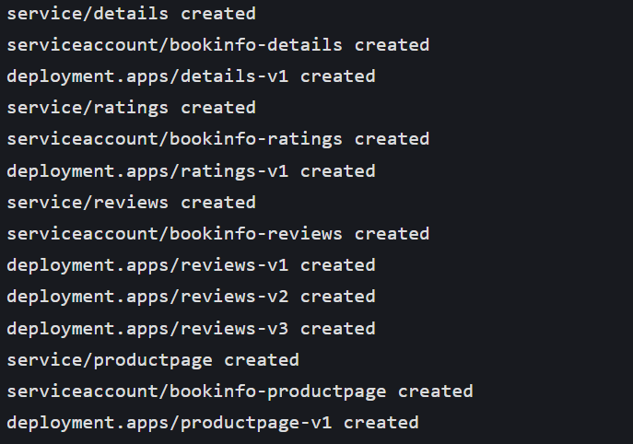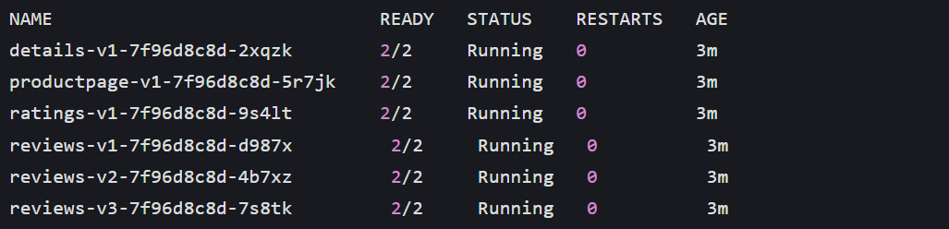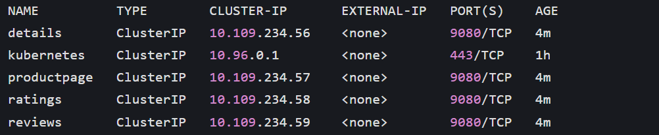Step 3: Expose the App with Istio Gateway
Create Istio Gateway & VirtualService
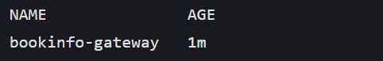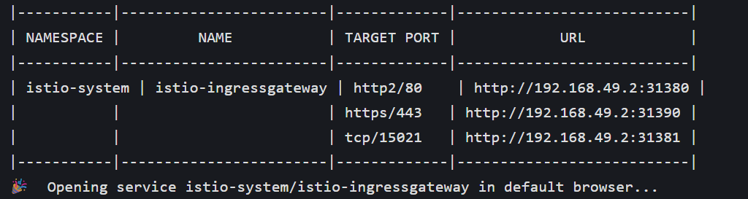Step 4: Verify Service Mesh Traffic Flow
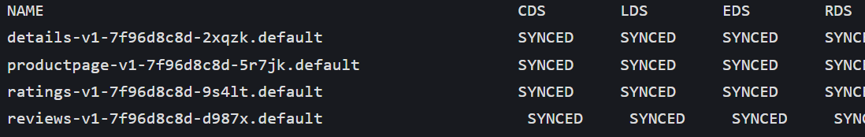Step 5: Traffic Management (Route to Specific Versions)
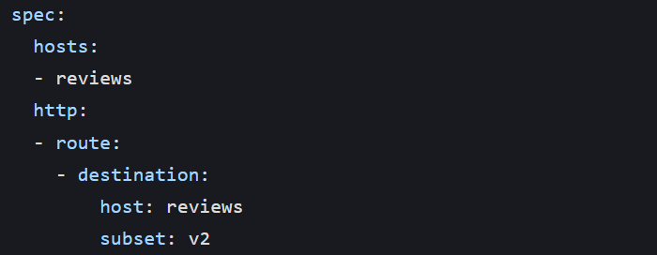Step 6: Explore Istio Observability (Kiali Dashboard)

